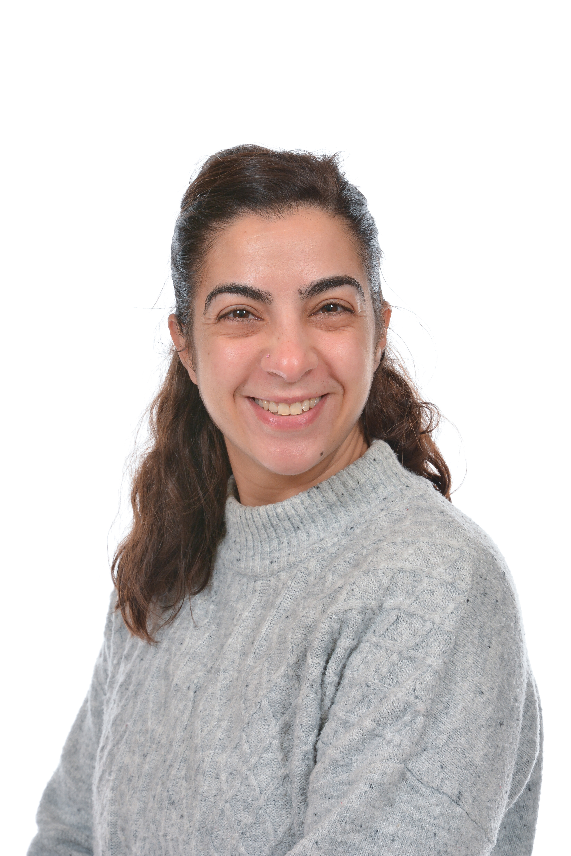

“Hello everyone!”

Hello, my name is Mrs Menevili, I am the Deputy Nursery Leader within Ash and Aspen. I am so excited to meet you and looking forward to having lots of fun playing and learning.

In the Autumn term our topic will be “All about me”, “People that help us” and being very busy with Christmas celebrations, where we will be doing lots of singing, so please get those lovely singing voices ready. During this period, we will be getting to know each other better, such as our names and favourite toys to play with, but most of all making new friends.

In the Spring term we will get a chance to share stories and learning about transitional tales in our topic, “storyland”.

Last of all in the Summer Term, we will be learning about ‘Under the Sea’ this is an exciting time for us all, we will be given the opportunity to learn all about sea creatures and use our imaginative skills, most of all we can all dress up as a sea creature for our end of term party.

I can’t wait to meet you all.

Mrs Menevili