**Welcome to Fir class!**

**You’ve got me!**

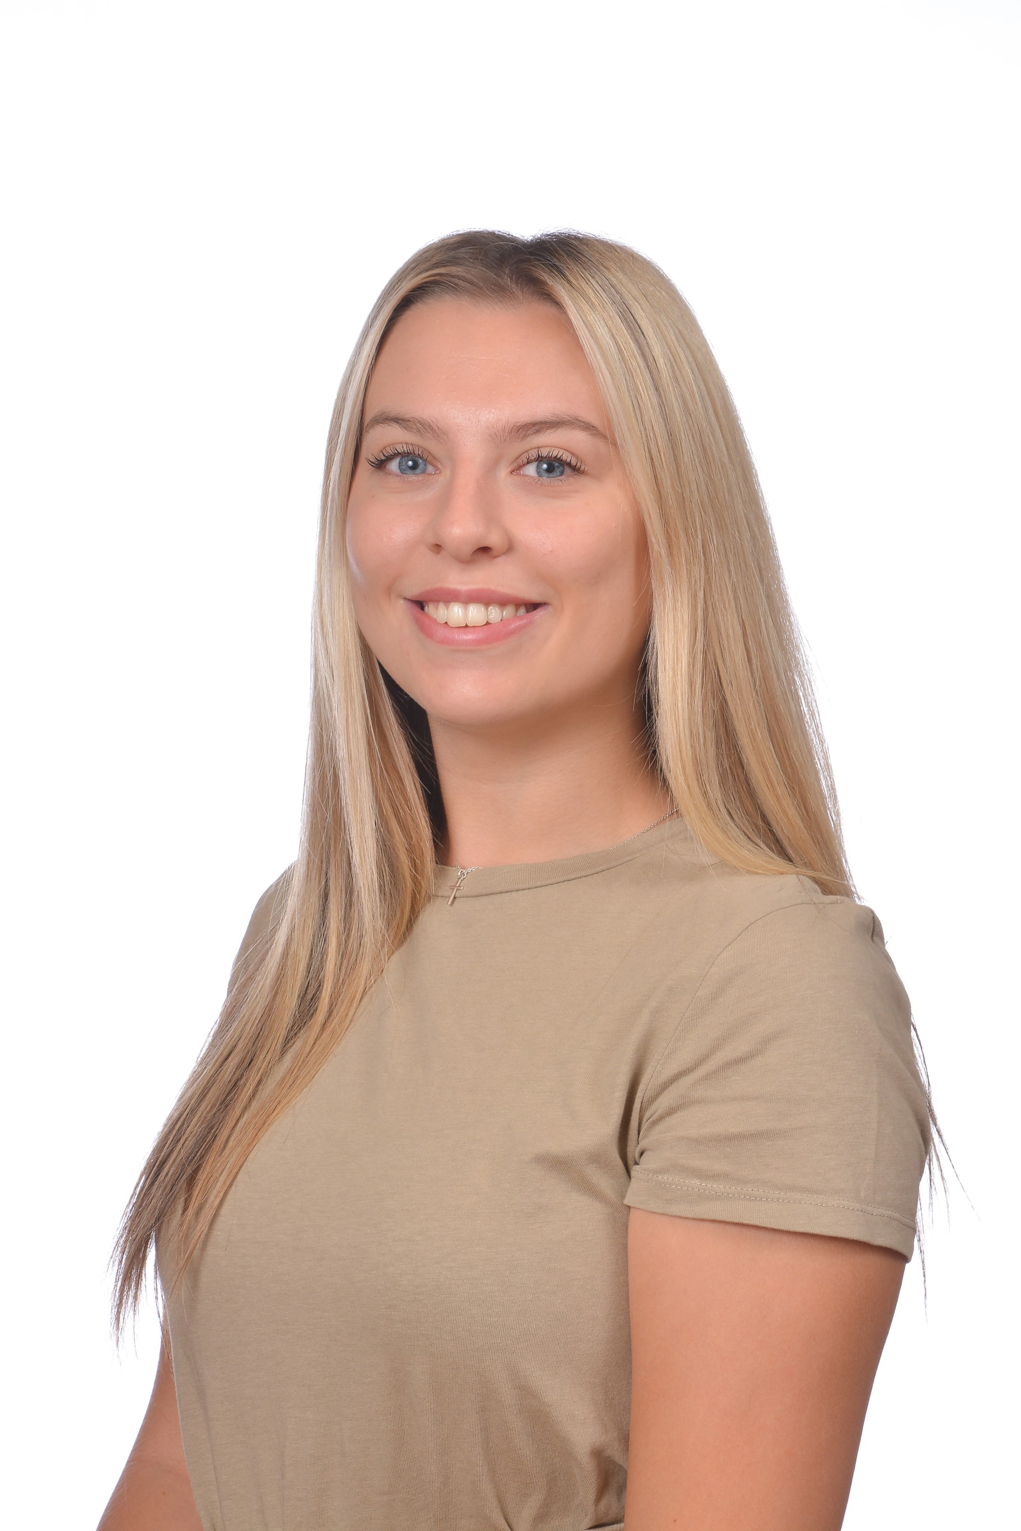

Hello, my name is Miss Bevans and I will be your Year 1 teacher. You will be in Fir class!

I’m looking forward to having lots of fun learning together! To begin our year 1 journey, we will be becoming superheroes and we will be planning what our superhero power will be for the year. It may be the power to work hard and always try your best or it could be to never give up and to be resilient. We will then be exploring the world of dinosaurs and Miss Sutherland and I have some really fun learning prepared for you, so be working on your very best dinosaur roar!

I hope you have a lovely summer break and I can’t wait to see you all again in September!

See you soon!

Miss Bevans