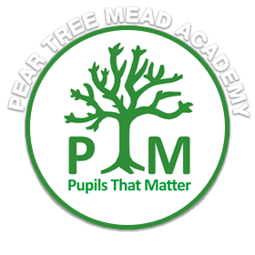

Hello Redwood!

I’m Mr Feast, and I’m really looking forward to teaching you this year. Some of you will already know me from previous years, and I can’t wait to see both familiar and new faces in my classroom. We will also have Mrs Fleming with us, another familiar face for some!

**About Me**

I enjoy pretty much every sport you can think of, and I support Liverpool – so you might hear me talking about football from time to time. I love music and play all sorts of instruments, from the piano to the ukulele, and I enjoy bringing music into the classroom whenever I can.

I also really enjoy drawing and doing any sort of art, so expect plenty of creativity in our lessons. When I’m not teaching, playing music, or doing art, you’ll usually find me reading – I’m a very avid reader and always looking for book recommendations, so let me know what you’re reading too.

Another thing about me is that I love board games and quizzes. I think learning should be fun and engaging, so you can expect some exciting activities and challenges this year.

**What We’re Learning This Year**

We have a brilliant curriculum ahead in Year 5. We’ll be learning about the Vikings, the Ancient Greeks (which is one of my favourites – you might have noticed some of my tattoos linked to Greek mythology), and World War II. I can’t wait to explore these topics with you and see your curiosity and knowledge grow.

I’m really looking forward to an amazing year with you all.

Mr Feast