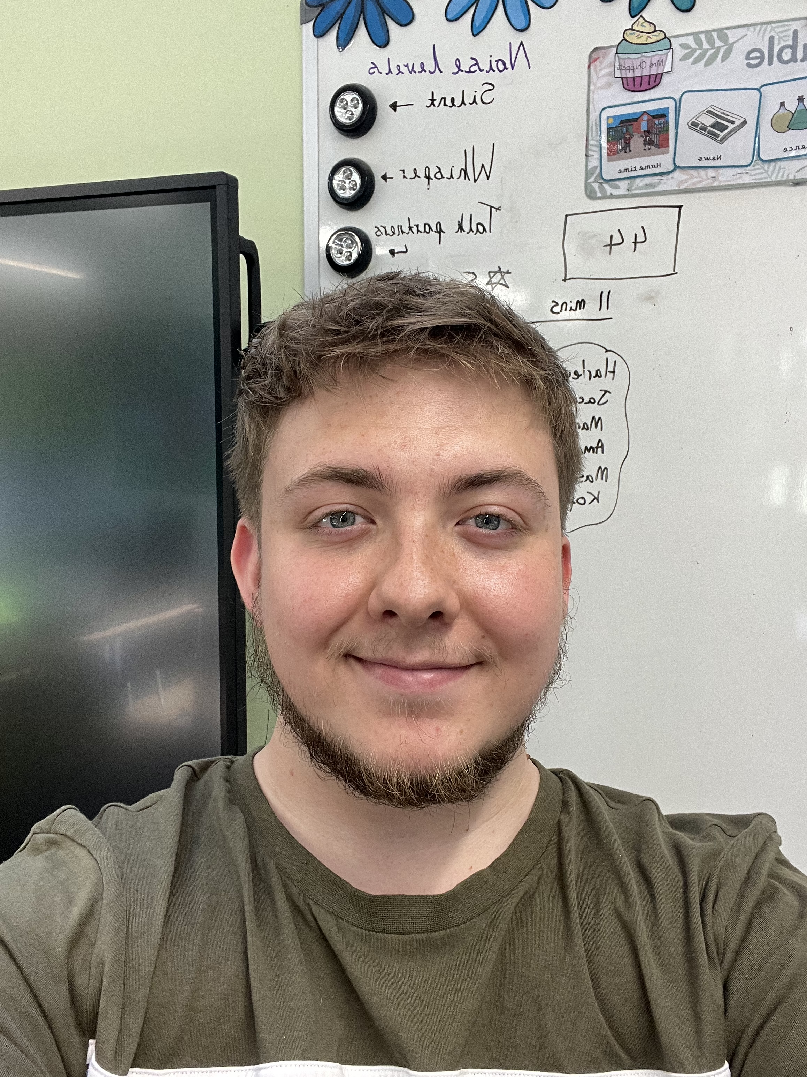Welcome to Mulberry Class

Hello,

I am very pleased to officially announce that I am going to be your year 3 teacher. We will also have Mrs White and Mrs Webb working as learning support assistants across both classes. I’m sorry we didn’t get to met today. Mrs Peden is going to organise for us to meet next week. I’m looking forward to meeting you all.

A little about me

I love music and football. I support Liverpool FC and enjoy watching football on the television. I like all kinds of music; I play the keyboard and I am going to join Rock band at school next year. I am looking forward to hearing about your favourite types of music and songs. I enjoy cycling, I cycle to work every day on my bike. I wonder how you get to school?

Our Year

We have a very exciting year planned for you. We start the year learning about the Stone Age and what life was like during this interesting period of time. We move on to learning about different countries, rivers, lakes and seas and compare life in two different European cities. We then finish the year with the Romans! We end out Roman topic by creating shields and acting out Roman army formations!

Over the summer holidays, I will be working to make our classroom a lovely and exciting place to learn in and to get it ready for you all in September!

I hope you have a lovely summer holiday, and I really am looking forward to seeing you all again and I can’t wait to have an amazing year in year 3!

Take care, stay safe,

Mr Feast