**Snow Day Activities.**

Here are some good ideas for keeping busy if the school is closed due to snow. If going outside remember to wrap up warm.

* Complete challenge 46 in 50 Things to do before you are 5. Catch a snow flake on your tongue.
* Complete challenge 32 in 50 Things to do before you are 5. Make a snow angel and have a snowball fight.
* Collect a bowl full of snow to create a small world for toy animals or character; it could be a frozen world for Elsa and Anna or a polar bear.
* Make a snow construction site.

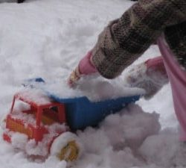

* Make patterns in the snow or write your name using a twig.
* Draw or wrap up warm and make a snowman or be adventurous and draw or build a snow cat or dog!

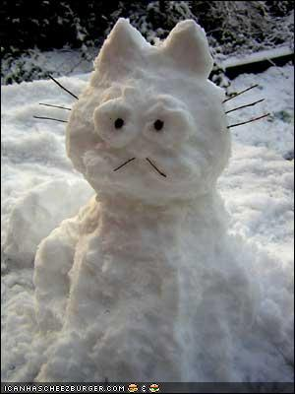

* Go on a listening walk to explore what sounds you can hear. Can you describe the sounds?
* Stomp through the snow and make footprints or look for animal prints.
* Have an indoor picnic.
* Make a snow fort

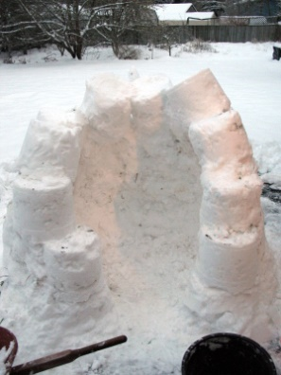

* Watch an icicle melt
* Make a snow flake from shapes.

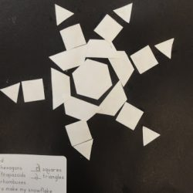

Whatever you decide to do have fun!